RedHat OpenShift Virtualization Services
Number: | Local Document |  | Status: |  | Draft
Owner: | Adrian Pohancanik |  | Effective: |  | 13. Feb 2026
Doc.- type: | Design |  | Revision |  | 0.1
Comments:
[Authorized by:  (Optional, delete if not required)] | [Name] | [Name] |  | [Name] |  | IT-MIO-INFRASTRUCTURE ENGINEERING
[Authorized by:  (Optional, delete if not required)] | [Department] | [Department] |  | [Department] |  | IT-MIO-INFRASTRUCTURE ENGINEERING

Table of Contents

1. Purpose 1

2. Scope 1

3. Summary 1

4. IT Infrastructure Service Definition 1
4.1 Service Description 2
4.2 Server Tier Classes 4
4.3 Service Levels 5
4.4 Service Level Agreements 6
4.5 Service elements included 7
4.6 Server vCPU Overcommit 8
4.7 Additional Availability Group Option 8
4.8 Server Sizes 9
4.9 Server Data Disks 10
4.10 Server Operating Systems 10
4.11 Storage 11
4.12 Storage Availability Classes 12
4.13 Storage Performance Classes 13
4.14 Backup 13

5. Security Concept 14

6. Contacts 14

7. Definition / Terms and Abbreviations 14

8. Employee Roles and Responsibilities 15

9. Related Documents / References 15

10. History 15

Purpose
The purpose of this document is to provide the set of minimal requirements which go together to define an IT Infrastructure Service. This is to provide additional guidance when services are created.

Scope
The scope of this document is limited to the IT-MIO-INFRASTRUCTURE ENGINEERING.

Summary
This document provides a definition of an IT Infrastructure Service. It is intended for IT infrastructure teams responsible for designing, configuring, and delivering services. Each block includes a clear purpose, detailed description, and proposal implementation requirements. This ensures consistency, security, compliance, and operational excellence across all infrastructure services.

IT Infrastructure Service Definition
Service Identification

Service Name: DN Virtualization Infrastructure Service
Service Owner: Infrastructure Engineering team
Service Category: Cloud Infrastructure / Virtualization Platform
Service Status: Technical Preview
Supported Versions: OpenShift 4.19 and later with OpenShift Virtualization Operator

4.1 Service Description
This virtualization service delivers a modern, Kubernetes‑based platform for hosting and managing virtual machines across enterprise IT environments. It enables organizations to provision, operate, and maintain virtual machines with improved efficiency, consistency, and automation. By leveraging a unified orchestration framework, the service helps reduce operational complexity, streamline lifecycle management, and support digital transformation initiatives centered around workload modernization.
Designed as an integrated component of the broader infrastructure platform, the service provides a standardized way to deploy and manage both Linux and Windows virtual machines using familiar Kubernetes APIs and a centralized management interface. This ensures greater operational alignment, simplified governance, and the flexibility needed to scale resources in response to evolving business demands.

Service Scope

In Scope
- Deployment and management of OpenShift Virtualization components
- VM provisioning, lifecycle management, and orchestration
- Integration with OpenShift networking and storage infrastructure
- High availability and disaster recovery capabilities
- Security, compliance, and access control for VM workloads
- Monitoring, logging, and performance management
- Live migration and workload mobility
- Support for hybrid VM and container environments

Out of Scope
- Physical infrastructure provisioning (compute, storage, networking hardware)
- Guest operating system support and patching
- Third-party virtualization tools or unsupported hypervisor configurations
- Custom application development or deployment
- End-user support for applications running on VMs

Service Components

Core Infrastructure
- OpenShift Container Platform: Kubernetes-based orchestration platform
- OpenShift Virtualization Operator: Automated deployment and lifecycle management
- KubeVirt Runtime: Open-source virtualization engine for Kubernetes
- Containerized Data Importer (CDI): VM image and disk management
- Virtctl CLI Tool: Command-line interface for VM operations

Supporting Services
- Networking: Software-Defined Networking (SDN) with multi-network support
- Storage: Persistent volumes backed by enterprise storage solutions
- Security: RBAC, network policies, and encryption
- Monitoring: Prometheus metrics, Grafana dashboards, and alerting
- Logging: SIEM Centralized log aggregation and analysis

Service Capabilities

Virtual Machine Management
- Provisioning: Create VMs from templates, images, or cloud-init configurations
- Lifecycle Operations: Start, stop, pause, resume, and delete VMs
- Live Migration: Move running VMs between cluster nodes with zero downtime
- Snapshots and Cloning: Create VM snapshots and clone existing VMs
- Resource Allocation: Define CPU, memory, and storage requirements per VM

Networking
- Multi-Network Support: Attach multiple network interfaces to VMs
- Network Policies: Enforce ingress/egress traffic rules
- Service Integration: Expose VM services via OpenShift services and routes
- DNS Resolution: Integrated DNS for VM discovery and communication

Storage
- Persistent Volumes: Attach persistent storage to VMs
- Storage Classes: Support for multiple storage backends (NetApp, DELL PFMx)
- Image Management: Import, manage, and distribute VM disk images
- Backup Integration: Support for backup and recovery solutions

Security and Compliance
- Role-Based Access Control (RBAC): Fine-grained access control for VM resources
- Network Segmentation: Isolate VM traffic using network policies
- Encryption: Support for encrypted storage and network traffic
- Audit Logging: Track all VM operations and configuration changes
- Compliance: Alignment with industry standards (ISO 27001, PCI DSS)

High Availability and Disaster Recovery
- Automatic Failover: Restart failed VMs on healthy nodes
- Live Migration: Move VMs without service interruption
- Cluster Redundancy: Multi-node cluster architecture for resilience
- Backup and Recovery: Integration with enterprise backup solutions

Monitoring and Observability
- Performance Metrics: CPU, memory, disk, and network utilization
- Health Checks: Liveness and readiness probes for VM health
- Alerting: Proactive notifications for anomalies and failures
- Dashboards: Real-time visibility into VM and cluster status
- Audit Trails: Complete logging of administrative actions

Service Delivery Model

Deployment Options
- On-Premises: Deployed on customer-managed OpenShift clusters
- Hybrid Cloud: Span workloads across on-premises and cloud environments
- Managed Service: Optionally managed by Red Hat or certified partners

Access Methods
- Web Console: Intuitive graphical interface for VM management
- CLI (oc/virtctl): Command-line tools for automation and scripting
- REST APIs: Programmatic access for integration and automation
- Infrastructure-as-Code: Declarative management via YAML manifests

Support and Maintenance
- Red Hat Enterprise Support: Included with OpenShift subscriptions
- Patch Management: Regular security and feature updates
- Documentation: Configuration standard guides and best practices
- Training: Professional services available

OpenShift Virtualization Provides

- Integrated VM and Container Management: Run traditional VM workloads side-by-side with containers on the same OpenShift platform.
- Kubernetes-Native Virtualization: Manage VMs using Kubernetes APIs and tools, enabling unified orchestration.
- High Availability and Scalability: Benefits from OpenShift’s clustering and scaling features for VMs.
- Simplified Dev/Test Environments: Quickly provision VMs for development and testing within the same infrastructure that runs production containers.
- Migration and Modernization: Helps modernize legacy applications by running them as VMs alongside new containerized apps.
- Networking and Storage Integration: Provides integration with OpenShift networking and storage for VM workloads.

In summary, OpenShift Virtualization allows organizations to converge VM-based and cloud-native workloads using a single, Kubernetes-based platform to improve operational efficiency.

Supported Workloads

- Legacy applications requiring VM environments.
- Hybrid workloads mixing VMs and containers.
- Development and testing environments needing multiple workload types.
- Application modernization projects transitioning from VMs to containers

- Run VMs and Containers on One Platform
- Smooth Migration from VMware or RHV
- Live Migration, Fault tolerance, and High Availability
- Hardware Acceleration and Passthrough
- Strong Security, Access Control, and Workload Isolation
- Networking for Virtual Machines
- Enterprise Storage and Data Management
- VM Lifecycle Operations
- Automation, GitOps, and CI/CD

4.2 Server Tier Classes
5 different Server Tier Classes:

Bronze: Simple VM with low requirements e.g. for Testing.
- Operating time: Monday - Friday 5x9h (08:00-17:00)
- VM is hosted on a random Host in an OpenShift Cluster, without any HA or DR features.

STAC: Copper
STPC: Bronze

Silver: One VM for productive usage with HA and Backup
- Operating time: Monday - Sunday 7x24h (00:00-24:00)
- VM is hosted on a random Host in an OpenShift Cluster.

STAC: Iron, Steel
STPC: Gold, Silver

Silver+: One VM for productive usage with HA, Backup and Disaster Recovery Support.
- Operating time: Monday - Sunday 7x24h (00:00-24:00)
- VM is hosted on a random Host in an OpenShift Cluster.
- With DR capabilities.

STAC: Iron, Steel
STPC: Gold, Silver

Gold: Scalable number of active VMs for Cluster Services with HA and Backup
- Operating time: Monday - Sunday 7x24h (00:00-24:00)
- 2 → 10* active VMs hosted on separate Hosts in an OpenShift Cluster. (* up to the number of available Worked Nodes)
- Cluster service will be provided by application.
- For cluster VMs rack level availability / Worker Node pools (DC Rack zooning 1,2,3…)

STAS: Steel
STPC: Gold, Gold

Gold+: Scalable number of active VMs for Cluster Services with HA, Backup and Disaster Recovery Support.
- Operating time: Monday - Sunday 7x24h (00:00-24:00)
- 2 → 10* active VMs hosted on separate Hosts in an OpenShift Cluster. (* up to the number of available Worked Nodes)
- Cluster service will be provided by application.
- With DR capabilities.
- High RPO RTO
- For cluster VMs rack level availability / Worker Node pools (DC Rack zooning 1,2,3…)

STAS: Steel
STPC: Gold, Gold

4.3 Service Levels

Operating time
​Gold & Gold+ | ​Monday - Sunday 7x24h (00:00-24:00)
​Silver & Silver+ | ​Monday - Sunday 7x24h (00:00-24:00)
​Bronze | ​Monday - Sunday 7x24h (00:00-24:00)

Service Tier | Region | Service time | On call Support
​Gold & Gold+ | EMEA  US  APAC | ​08:00-17:00 Monday to Friday  08:00-13:30 Monday to Friday  06:00-00:00 Monday to Friday | In the off Business hours and weekends. On call person will handle the incidents also approved changes.
​Silver & Silver+ | EMEA  US  APAC | ​08:00-17:00 Monday to Friday  08:00-13:30 Monday to Friday  06:00-00:00 Monday to Friday | In the off Business hours and weekends. On call person will handle the incidents also approved changes.
​Bronze | EMEA  US  APAC | ​08:00-17:00 Monday to Friday  08:00-13:30 Monday to Friday  06:00-00:00 Monday to Friday | No On call support for this service tier.

​Service Class Values ​ ​ ​ ​
Class | Availability ​ | Dtpm | Dtpi | ​#Fail/y | RPO​
​Gold+ | 99.8 %​ | ​1.44h | 1.44h​ | 4​ | Standard defined RPO
​Silver+ | ​99.5 % | 2.06h​ | ​2h | ​8 | Standard defined RPO
​Bronze | ​98.0% | ​4.60h | ​4h | ​12 | ​-
Dtpm = Downtime per month, Dtpi = Downtime per incident, #Fail/y = Failures per year, RPO = Recovery Point Objective

(*) Overview of the scope of service and service levels. For a detailed description please see the statement of work.

4.4 Service Level Agreements

Service Level Agreements
Metric | Bronze | Silver | Silver+ | Gold | Gold+ | Definition / Notes
Platform Availability (per month) | ​98.0% | 99.5 %​ | 99.5 %​ | 99.8 % | 99.8 % | Excludes approved maintenance windows
Incident Response – P1 | Within 2 business hour | 1hour on working days; on-call for off-hours | 1hour on working days; on-call for off-hours | 30 minutes (business hours); on-call for off-hours | 30 minutes (business hours); on-call for off-hours | Time to acknowledge
Incident Restore – P1 | Best effort | 4 hours (target) | 4 hours (target) | 2 hours (target) | 2 hours (target) | Time to service restoration or workaround
Incident Response – P2 | 4 business hours | 2 business hours; on-call for off-hours | 2 business hours; on-call for off-hours | 1 hour (business hours); on-call for off-hours | 1 hour (business hours); on-call for off-hours | Acknowledgement time
Change Lead Time (Std) | Best effort | ≥ 7 business days | ≥ 7 business days | ≥ 14 business days | ≥ 14 business days | From approved RFC to implementation
Problem Management RCA | Within 10 business days | Within 7 business days | Within 7 business days | Within 5 business days | Within 5 business days | RCA for P1/P2 incidents
Backup Frequency | Daily | Daily | Daily | Daily | Daily | PVCs, metadata
Disaster Recovery RPO | N/A (no DR commitment) | N/A (no DR commitment) | 1 hour | N/A (no DR commitment) | 30 mins | Platform-level objectives; app DR may differ

4.5 Service elements included

​Service Element | ​Content
​Installation and operation | ​of hardware, virtualization layer, operating system and operating system related software
​IT operation | ​Establishing / maintaining the operational readiness
Service documentation | Service documentation will be maintained via ongoing process
​Vendor management | ​Maintaining ownership and management responsibility for the platform including the operating system.
​License management | ​Ensuring that license reporting for the license manager is functional, implementing best practice architecture to ensure license compliance and vendor management.
​Access management | ​User policies, administration and password management enforcement based upon corporate standards.
​Configuration management | ​Confirming the initial install and basic functionality levering a hardened operating system configuration based upon vendor, 3rd Party best practices and corporate standards.
​ | ​Add-on service to account for additional OS configurations for your services putting these then into your image configuration for repeated deployment.
​Change management | ​Providing ITIL-based internal change control when relevant for the service
​Patch / update management | ​Offering automated support for all critical and vendor-recommended patches for the deployed OS versions. The actual patching of the deployed services lies within the responsibility of the service consumer.
​Operational security measures | ​Securing the OS (where applicable) with anti-virus protection, regular virus and malware signature updates and additional OS-level hardening based upon GRS standards.
​Service deployment | ​Deployment of services to the customer's network as requested by the client from the standard service catalogue.
​Service monitoring | ​Monitoring provides the DN Engineering team with information about and monitoring of the operation and performance of Servers including CPU, disk and memory performance. The appropriate monitoring metrics and thresholds are based upon standards and cannot be individually requested.  But at the end of the day, the customer himself is responsible for monitoring his whole application. Only he knows the architectural design and possible hotspots inside. He's free to use the available elementary monitoring in that way he wants.

4.6 Server vCPU Overcommit

Service Scope

- Provisioning and operation of OpenShift Virtualization with CPU overcommit set to 1:4.
- Supports mixed workloads where VMs do not continuously consume 100% CPU.
- Includes guidance on scheduling, capacity planning, and performance safeguards.

Customers Can Expect from vCPU Overcommit:

- Maximize hardware utilization
- Run more VMs on the same physical infrastructure
- Higher VM density
- Good performance for typical workloads
- Kubernetes scheduling awareness
- Flexible CPU allocation

4.7 Additional Availability Group Option
With the additional availability group option to have the possibility to extend the amount of active VMs hosted on separate hardware hosts above the Gold class definition of 2 if required. This is an add-on option to the gold class service.
In addition to the gold class service definition, you can additionally:
- Define the group and add individual servers (>2) to this group after deployment.
- Grouping is limited to the tenant and Microsoft and Linux cannot be mixed within a single group.

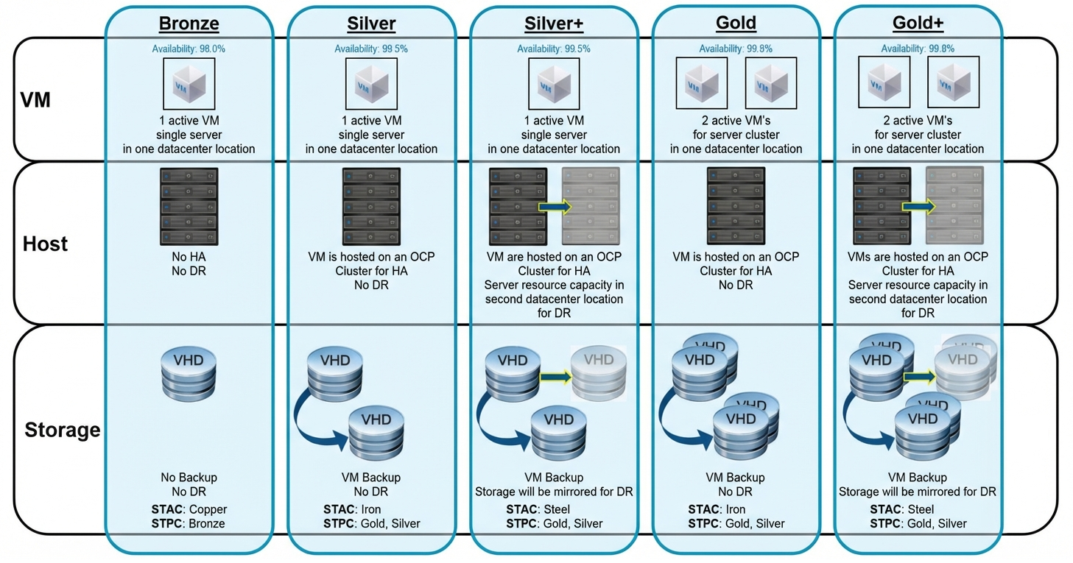

STAC = Storage Availability Class STPC = Storage Performance Class

4.8 Server Sizes
Each instance type includes one or more instance size, allowing you to scale your resources to the requirements of your target workload.
The Service offering for managed OS includes several different standard sizes. These can be extended with additional CPU and / or RAM. The following Table shows the combination of the
Types and the VM properties such as vCPU, vRAM and OS. In general the table provides an overview about the baseline level of CPU. The Performance values for the
VM are defined in the row by number of vCPU, vRAM per OS and furthermore by the Storage classes.
The customer starts with an Instance type and can scale up and down if necessary. The OS types on offer are Linux and Windows.

Instance Type | vCPU | vRAM (GB) | OS Linux | OS Windows
Tiny | 1 | 2 | X | --
Small_1 | 2 | 2 | X | X
Small_2 | 2 | 4 | X | X
Medium_1 | 4 | 8 | X | X
Medium_2 | 4 | 16 | X | X
Large_1 | 8 | 16 | X | X
Large_2 | 8 | 32 | X | X
​ ​ ​ ​
Slice CPU | 2 | -- | Range from 2 to 16 in total
Slice RAM | -- | 2 | Range from 2 to 128 in total

Instance Type of Server as VM

4.9 Server Data Disks

VM disks → Data Volumes → Persistent Volumes For Data
Features & Functions | Provides Virtual Machine Disk (LUNs) to store your data.
Eligibility & Prerequisites | Service available for all existing VM's. Disk is always dedicated and stored with respective VM on the same Storage Class and configured with respective IOPS.
​Size | Multiplication of 50 GB, up to 5 TB.
​Performance Class | ​Same as Server Class.
​Availability Class | Same as Server Class​.

4.10 Server Operating Systems

Vendor | ​Operating System | ​OS Parameter | ​Release | ​Release Status | ​End of Mainstream Support | ​End of Patch Support (EoL) | ​End of Platform operation
​Microsoft | ​Windows Server 2016 | ​ - User Interface: English  - for x86 processors  - 64-bit architecture  - 100GB OS dedicated partition | ​N - 1 | ​Released | ​01.11.2022 | ​12.01.2027 | ​​11.08.2026
​Microsoft | ​Windows Server 2019 | ​​ - User Interface: English  - for x86 processors  - 64-bit architecture  - 100GB OS dedicated partition | ​N | Released | ​09.01.2024 | ​09.01.2029 | 08.08.​2028
​Microsoft | ​Windows Server 2022 | ​​ - User Interface: English  - for x86 processors  - 64-bit architecture  - 100GB OS dedicated partition | ​N | Released | ​09.01.2024 | ​09.01.2029 | 08.08.​2028
​Oracle | ​Oracle Enterprise Linux 8 | ​- User Interface: English  - for x86 processors  - 64-bit architecture  - 50GB OS partition | ​N | ​Released | ​July 2029 | ​Not defined yet | 31.12.2028
​Oracle | ​Oracle Enterprise Linux 9 | ​- User Interface: English  - for x86 processors  - 64-bit architecture  - 50GB OS partition | ​N | ​Released | ​30.06.2032 | ​Not defined yet | 30.06.2035

End of Vendor Support - After this date the vendor no longer: accept support calls, supplies non-security hotfixes, no long accepts requests for new features and design changes.
End of Patch Support - The Date until security and critical patches are still being supplied.
We offers N Support until Vendor Support is discontinued and N -1 until Security and critical patches are no longer available. Version which is marked as Out of support is fully managed by server owner including patch, vulnerability management. Be aware however that Vendor support calls and feature requests outside of the Vendor Support period are not possible. The platform does not provide any SLA for those products.
DN Engineering team recommends always to choose Version N.

* we will not support outside of N -1. This means that the OS can no longer be provisioned or managed.

* You are to ensure the migration in your architecture to either N or N -1.
Currently only one Version of Linux is being offered. This is pending a change of Linux distribution.
RHEL 7.* will still be available but with an expected higher OS License Cost.

4.11 Storage
The storage services provides additional Storage to Host systems. The currently available services are designed to provide storage for Database applications and File sharing, they are highly scalable in capacity and throughput performance.
Additional disks are not part of this service.
Delivers various storage classes for different demands.

​Storage Classes | ​Description | Class types​
​STAC | ​Storage Availability Classes | ​Copper, Iron, Steel
​STPC | ​Storage Performance Classes | ​Bronze, Silver, Gold

4.12 Storage Availability Classes

Copper: Redundant storage system in 1st DC
- Operating time: Monday - Friday 5x9h (08:00-17:00)
- is directly attached to the storage controller. There are some restrictions for the HA scenario because in the case of Copper a multipath storage connection with
additional controller has to be established.

Iron: Redundant storage in 1st DC and backup to 2nd DC
- Operating time: Monday - Sunday 7x24h (00:00-24:00)
- is HA ready and connected with redundant metrics such as multipath and an additional controller to the local storage. This class is not ready for DR.

Steel: 2x Redundant storage in 1st+2nd DC's with async mirror and backup to 2nd DC
- Operating time: Monday - Sunday 7x24h (00:00-24:00)
- is HA and DR ready. The Recovery Point Objective (hereinafter called RPO) is technically defined via an asynchronous mirror between the two DCs for "Steel".
The recovery time is 8 hours in a case of DR.

The following overview shows the different classes and in which manner they are to be operated.

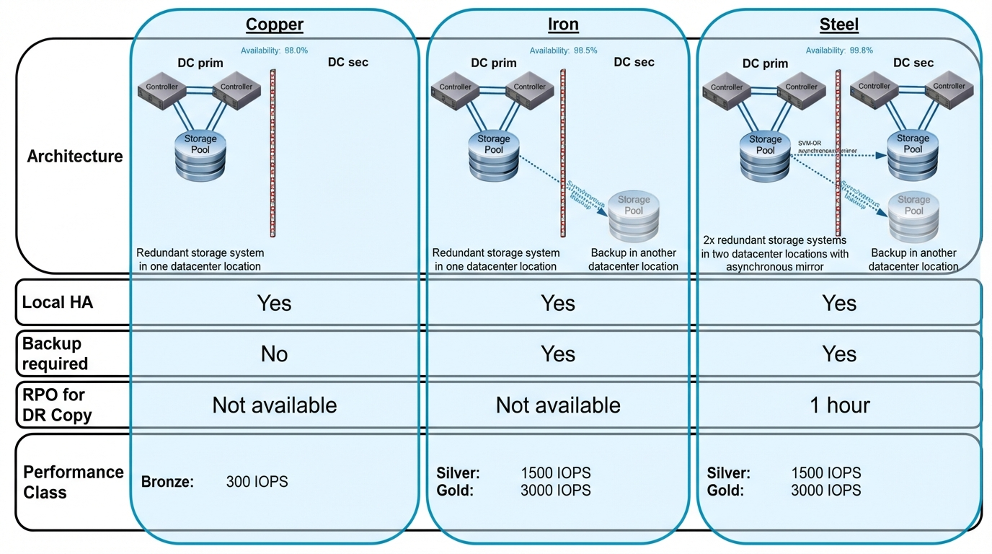

4.13 Storage Performance Classes

Storage Class:

Class Name | IOPs | Expected Service Tier to be Opted
Bronze | 300 | Bronze, Silver
Silver | 1500 | Silver+, Gold
Gold | 3000 | Gold+

4.14 Backup
Backup Service Overview
The Backup Service for OpenShift Virtualization provides standardized and reliable data protection for virtual machines (VMs) operating within the platform. The service ensures that VM-level backups are performed and retained in alignment with the requirements of the respective environment.

Backup Schedule
Virtual machines are backed up at a minimum frequency of once per day. Environments with higher operational or application requirements may define and implement more frequent backup intervals as needed.

Backup Retention and Storage Tiers
- Primary backup storage
Backups generated within the most recent two (2) days are stored on primary storage systems. This tier is intended to provide rapid access and support expedited recovery operations.

- Secondary Storage
Backups older than two days are transferred to secondary storage. Retention on this tier follows the retention policy defined for the specific environment ensuring compliance with organizational or regulatory requirements.

The following items are explicitly out of scope for this service:
- Application‑consistent snapshots, including those requiring quiescing or coordination with guest applications.
- Database‑level backups or any backup mechanisms that require integration with database engines, plugins, or agents.

On-Demand Virtual Machine Snapshot

In addition to regular backup service above.
The service includes single Virtual Memory Snapshot creation of all local disks without Memory (RAM) which is available for recovery up to 7 days (01:00 CEST) after snapshot creation.

Security Concept
Define the overall security architecture and compliance alignment.
Provides a comprehensive view of security, including access control, audit logging, and compliance mapping.

It ensures the service is resilient and audit-ready.
Requirements:
- Access control strategy (RBAC)
- Audit logging and retention policies
- Integration with SIEM/SOC
- Mapping to compliance frameworks, which controls are accounted for (ISO 27001, PCI DSS)
- Data protection and privacy controls

Contacts
[Insert statement regarding whom to contact if any issues or questions surrounding the subject matter of the document.]

Definition / Terms and Abbreviations
Term | Definition
[Document Control System] | [IT System to manage documents]
[DN] | [Diebold Nixdorf]
AD | Active Directory
OP | Operation teams (Linux, Windows, Backup, Storage)
OC | Red Hat OpenShift command-line interface (CLI)
OCP | Red Hat OpenShift Container Platform
namespaces | A namespace isolates specific system resources that are visible to all processes. Inside a namespace, only processes that are members of that namespace can see those resources
pod | One or more containers with shared resources, such as volume and IP addresses, running in your OpenShift Container Platform cluster. A pod is the smallest compute unit defined, deployed, and managed.

Employee Roles and Responsibilities
Role | Responsibility
[Quality Management] | [Controls and reviews the level of quality.]

Related Documents / References
Title | Number

History
Revision | Date | Comment | By
[0.1] | 15.12.2025 | [First draft version] | Stuart Evans

